Task 1

Topic: Take one Domain and draw the graph(Normal distribution, Empirical rule).

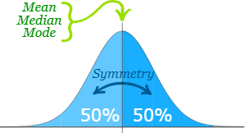

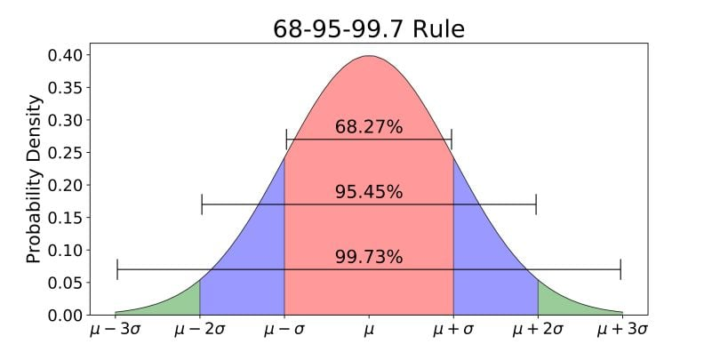

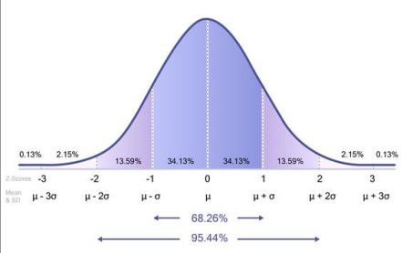

Normal Distribution Graph (Bell Curve):
In the domain of Student Exam Scores, marks often follow a Normal Distribution:
- The graph is bell-shaped
- The center is the Mean (μ) — average marks
- The spread is measured using Standard Deviation (σ)
- The curve is symmetrical
Example:
- Mean (μ) = 70 marks
- Standard Deviation (σ) = 10 marks

Empirical Rule (68–95–99.7 Rule):
The Empirical Rule applies to normally distributed data:
1 Standard Deviation (μ ± 1σ)
- 68% of students score between
60 and 80 marks
2 Standard Deviations (μ ± 2σ)
- 95% of students score between
50 and 90 marks
3 Standard Deviations (μ ± 3σ)
- 99.7% of students score between
40 and 100 marks

Explanation in Simple Points:
- Most students score around the average
- Very few students score extremely high or extremely low
- The curve helps teachers:
  - Understand performance distribution
  - Identify outliers
  - Grade on a relative scale

How to Draw in Exam:
- Draw X and Y axis
- Draw a bell-shaped curve
- Mark center as Mean (μ)
- Mark μ ± 1σ, μ ± 2σ, μ ± 3σ
- Write percentages:
  - 68%
  - 95%
  - 99.7%

